PATERN MATCH UPDATE
STEP 1.
Runt test process to allow test process to capture UUT logo image.
C:\SNAPSHOT.BMP
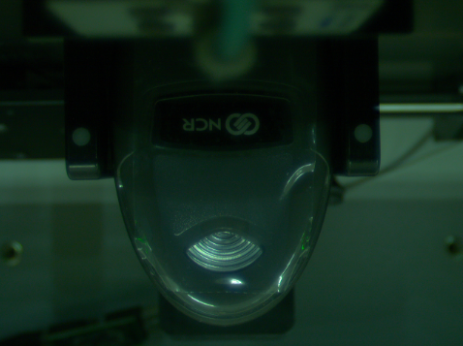
STEP 2.
Open Vision Assistant 2014.
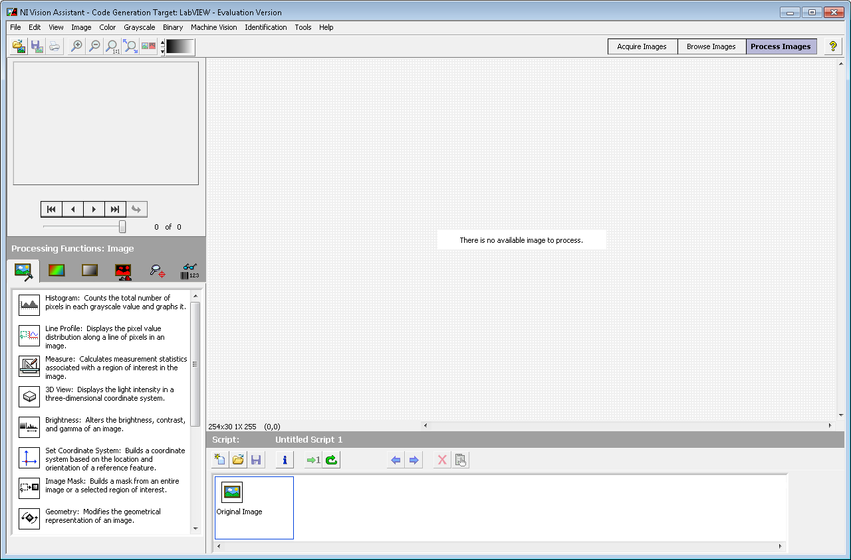
STEP 3.
Open file C:\SNAPSHOT.BMP
Open Script File C:\mtp\Site_Ne_sch\Projects\DS99_FAT\LED_LOGO_DETECT\TIMON LED AND LOGO VALIDATION_PATTERN_MATCH .vascr
Set Image on screen to “Zoom to Fit”
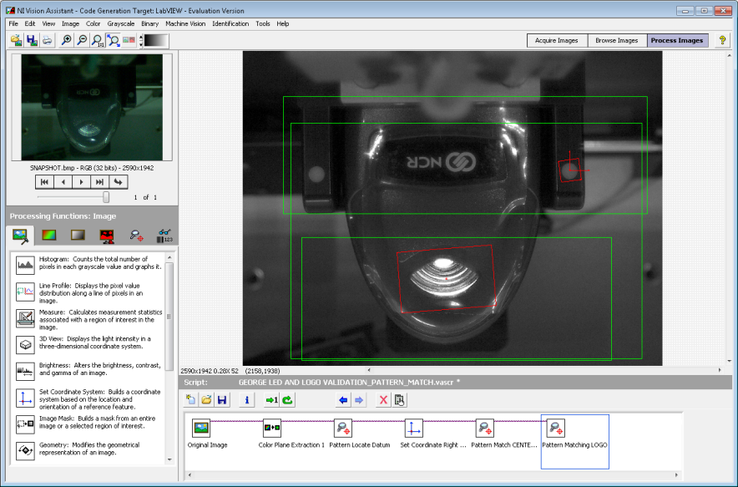
Step 4.
Edit Pattern Matching LOGO step
Create New Template image:
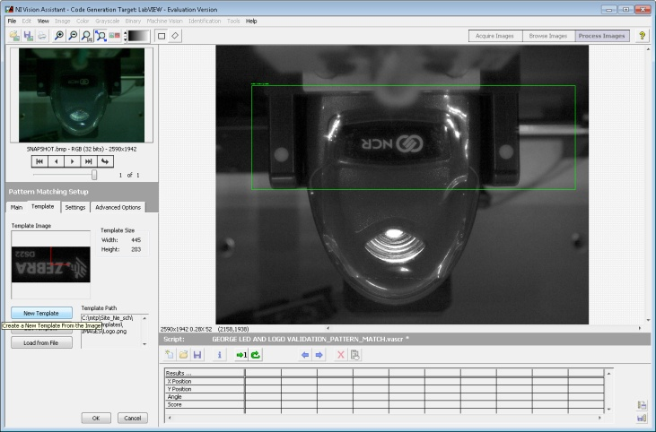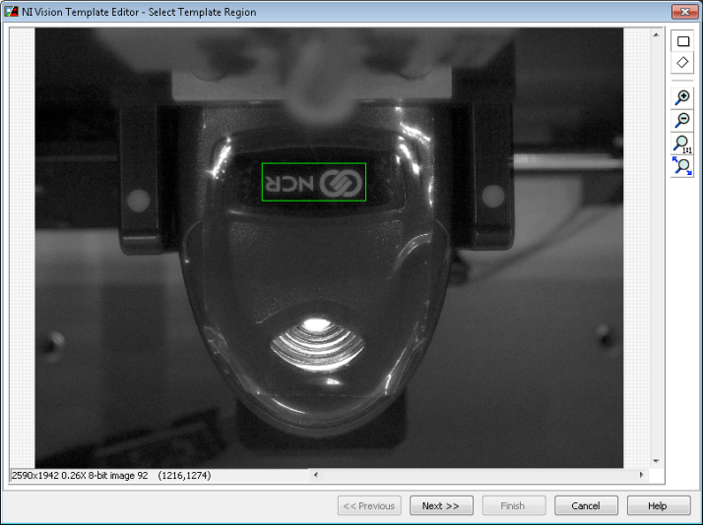
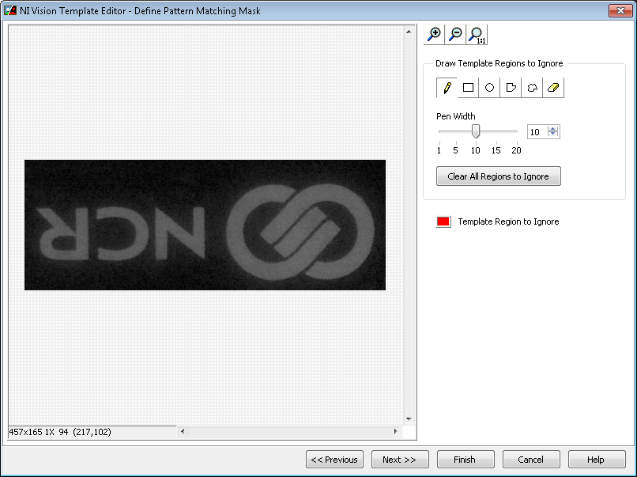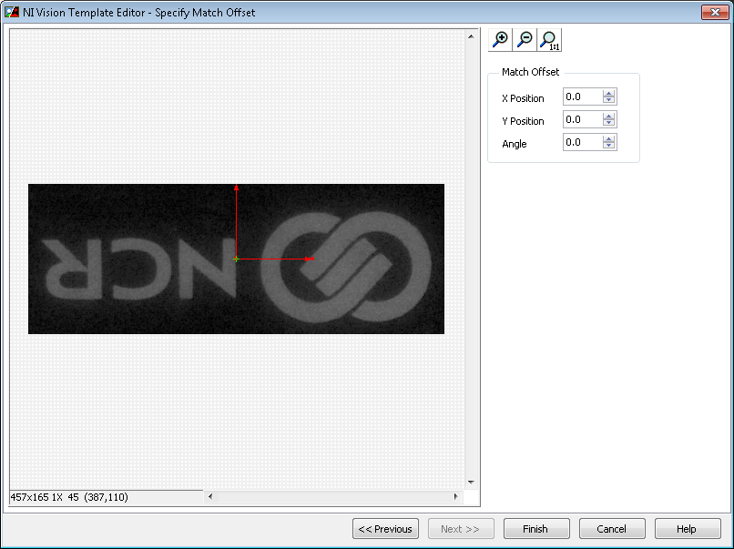
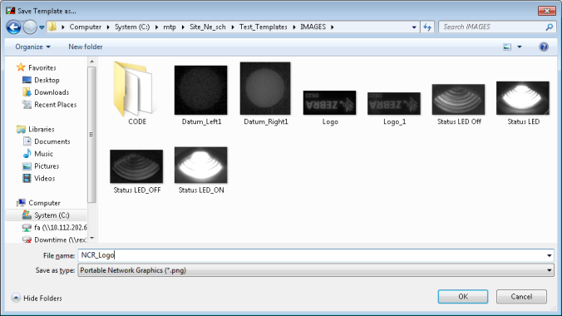
Save Image file C:\mtp\Site_Ne_sch\Test_Templates\IMAGES\ NCR_Logo.png
STEP 5.
Confirm Vision Assistant detect new Logo
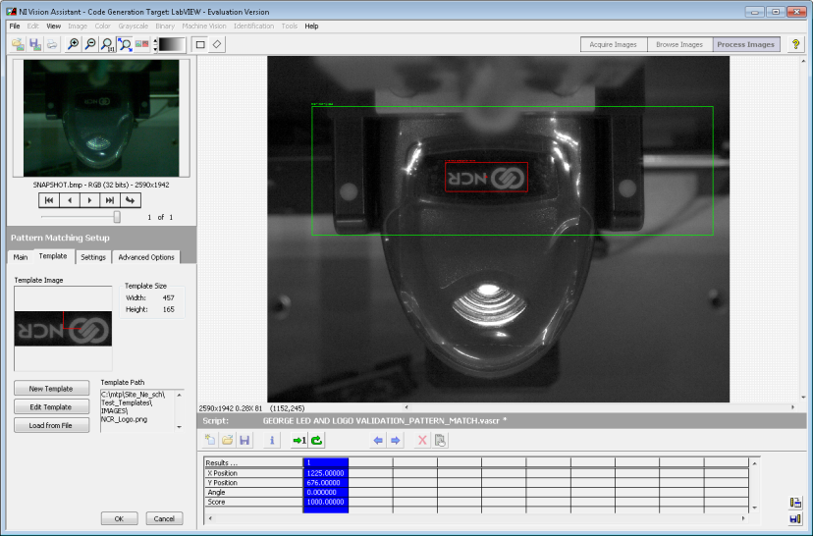

STEP 6.
Close Vision Assistant 2014.
Add NCR model 2356-2308-0000 to test datablock file” C:\mtp\Site_Ne_sch\Projects\DS22XX_FAT\DS22XX_FAT.DataBlocks to support the logo type based on the model number.